AERO62520
ROBOTICS RESEARCH PROJECT

CONFLICT RESOLUTION FLOWCHART

Student ID / Name
14505709 / Ting-Hsuan Su
14517856 / Yijian Wu
11184480 / Mark Milan Szedlak
11357288 / Han Zhang
14205477 / Keara Kingsellers

16/10/2026

Conflict Resolution Methodology
This document outlines the processes and methods that will be taken if a conflict occurs within the team or member of the team listed above. There are 3 different metrics to measure the level of conflicts, minor, moderate and serious and the steps to resolve them.

How to define the conflict level
The three levels of conflicts are minor, moderate and serious this section of the document outlines how to identify the conflict and categorise them into the groups respectively as shown in figure 1.
Severity Level | Key Indicators | Common Examples
Minor | - One off incident  - Zero impact to safety  - Easily brushed off or handled in minutes | - Disagreement over minor plans or preferences
Moderate | - Recurring pattern or unresolved issue  - Affects daily workflow  - Strains communication and trust | - Missing deadlines  - Not doing allocated work
Serious | - Threats to physical, emotion or organisational health  - Violates trust and safety of others  - Refusal to engage constructively | - Harassment, discrimination or abuse language
Figure 1 – Conflict Severity Identification Matrix
Conflict Resolution Flowchart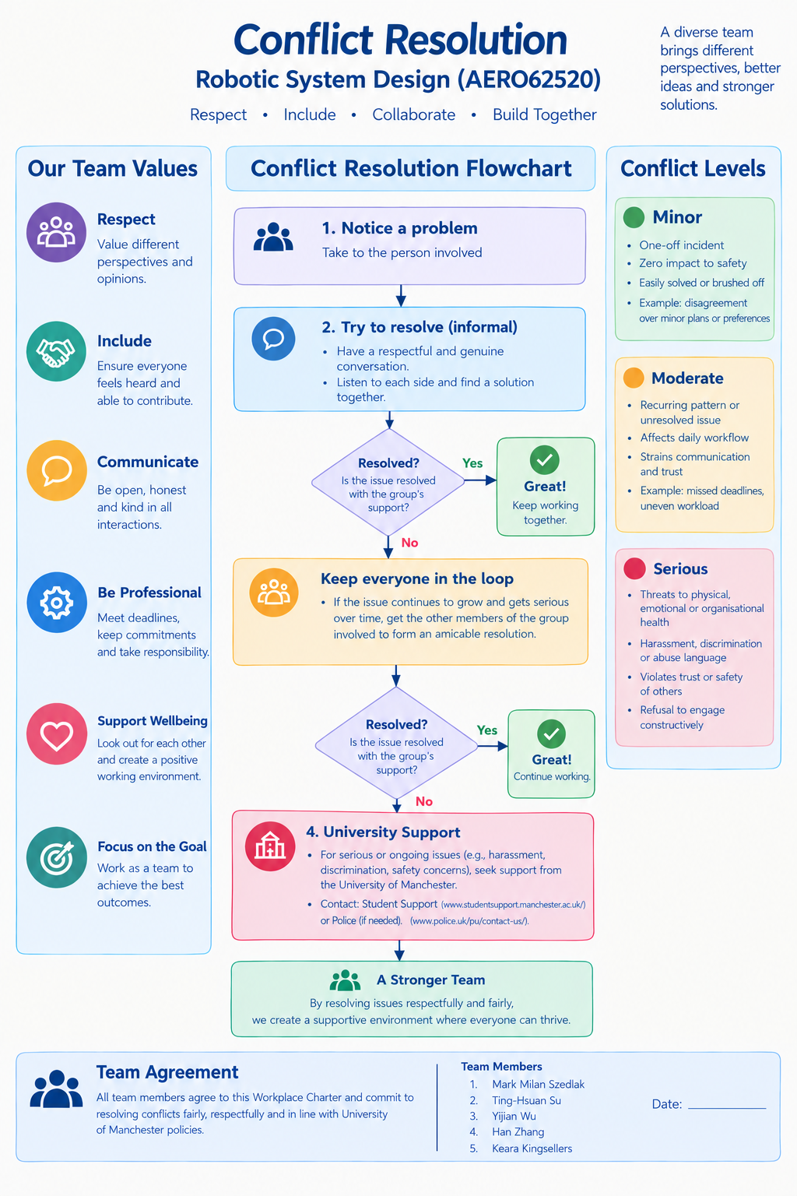

Resources for Serious Conflicts Resources used for flowchart
University of Manchester Support: https://www.studentsupport.manchester.ac.uk/
Police: https://www.police.uk/pu/contact-us/

Resources used for flowchart
http://researchgate.net/publication/52006546_Conflict_Management_in_Student_Groups_-_a_Teacher's_Perspective_in_Higher_Education
https://tarheelstateteacher.com/5-conflict-resolution-styles-teaching-activity/
https://cmaconsulting.com.au/top-conflict-resolution-activities-for-college-students/

Team Member Agreement
All team members listed in this document agree conflict resolution flowchart, on how conflicts will be resolved and measured.
- Mark Milan Szedlak
- Ting-Hsuan Su
- Yijian Wu
- Han Zhang
- Keara Kingsellers

